**Test Case 9**

**System:** Bench

**Description:** Test that the user is able to block a user’s incoming messages.

**Severity:** 3

**Instructions**

**Test 1**

1. Start the Bench application.
2. Click the button “Login” on the navigation bar.
3. Enter the email “user1@gmail.com” into the text field labeled “Email address”.
4. Enter the password “12345678” into the field labeled “Password”.
5. Click the button “Login” below the field.
6. After the screen has loaded, click on the button “Chat” on the navigation bar.
7. Click on any of the existing chat panels listed on the left sidebar.
8. Click on the profile photo on the top left corner of the chat room.

**Expected Result:** There should exist a button “Block”.

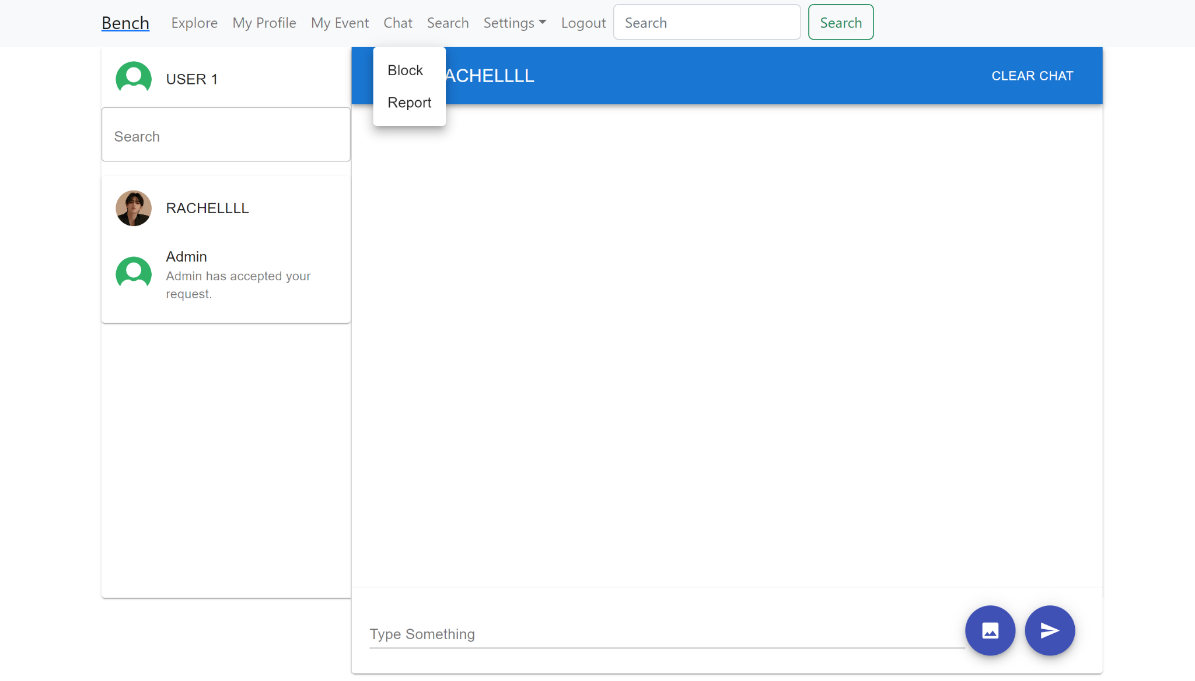

**Test 2**

1. Start the Bench application.
2. Click the button “Login” on the navigation bar.
3. Enter the email “user1@gmail.com” into the text field labeled “Email address”.
4. Enter the password “12345678” into the field labeled “Password”.
5. Click the button “Login” below the field.
6. After the screen has loaded, click on the button “Chat” on the navigation bar.
7. Click on any of the existing chat panels listed on the left sidebar.
8. Click on the profile photo on the top left corner of the chat room.
9. Click on the button “Block”.

**Expected Result:** The button “Block” should be clickable for the current user to block this selected user that has an existing chat room with them.



**Test 3**

1. On device “A”, start the Bench application.
2. Click the button “Login” on the navigation bar.
3. Enter the email “user1@gmail.com” into the text field labeled “Email address” to login as user user1.
4. Enter the password “12345678” into the field labeled “Password”.
5. Click the button “Login” below the field.
6. After the screen has loaded, click on the button “Chat” on the navigation bar.
7. Click on the existing chat panel labeled “RACHELLLL” on the left sidebar.
8. Click on the profile photo on the top left corner of the chat room.
9. Click on the button “Block”.
10. The chat panel labeled with the blocked user’s username, “RACHELLLL”, should be removed from the left sidebar on user1’s site on device “A”.
11. On device “B”, start the Bench application.
12. Click the button “Login” on the navigation bar.
13. Enter the email “rachel.la2310@gmail.com” into the text field labeled “Email address” to login as user rachellll.
14. Enter the password “12345678” into the field labeled “Password”.
15. Click the button “Login” below the field.
16. After the screen has loaded, click on the button “Chat” on the navigation bar.
17. Check the left sidebar for the list of existing accepted chat panels on Rachellll’s site on device “B”.

**Expected Result:** The chat panel between the two users, user1 and Rachellll, should be removed on both users’ chat lists on both users’ sites after one of the two users blocked the other.

